The classification results of different algorithms on the Liaohekou dataset are shown in Fig. 1. Overall, GMDFSL produces more accurate and spatially continuous classification maps than the other comparison methods. For region A, most methods suffer from obvious confusion between nearshore mudflat (C8) and Suaeda vegetation (C9), which is mainly attributed to their similar spectral responses. In contrast, GMDFSL effectively reduces this misclassification and maintains clearer boundaries. In region B, GSC-ViT, S3Net, DSFormer, GS-GraphSAT, and S3FAN show apparent confusion between shallow water (C2) and pond water (C5), whereas SPFormer and DEMAE alleviate this problem to some extent. GMDFSL achieves better discrimination between these two categories by incorporating spatial contextual information. In region C, S3Net and DEMAE incorrectly classify reed (C10) as Suaeda vegetation (C9), while GMDFSL obtains more consistent classification results. These observations demonstrate that GMDFSL can effectively exploit spectral characteristics and spatial dependencies, resulting in improved classification continuity and reduced category confusion under few-shot conditions.
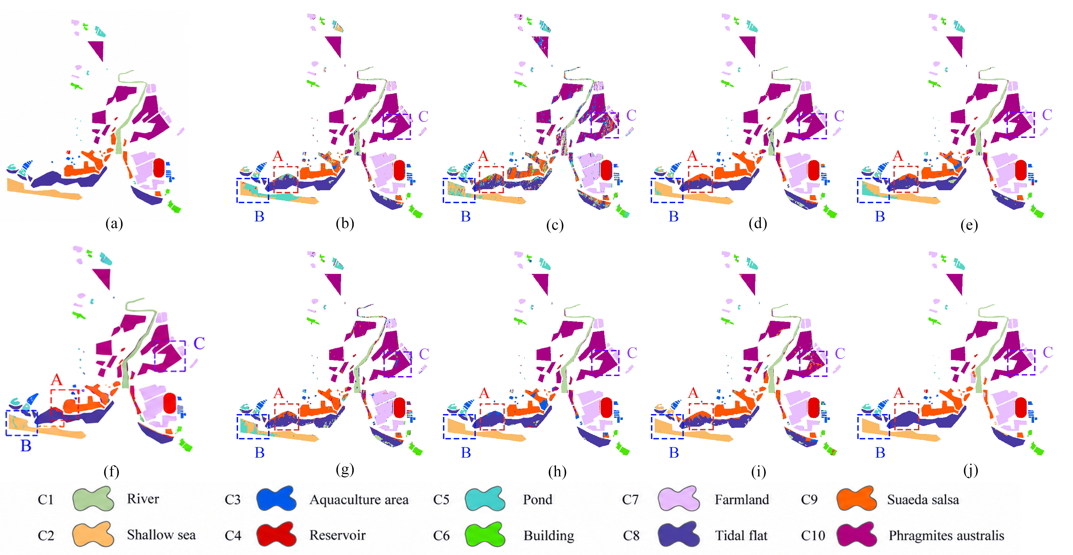
Figure 1 Classification results of different algorithms on the Liaohekou dataset.
The quantitative classification results on the Liaohekou dataset are presented in Table 1. GMDFSL achieves the best performance among all comparison methods, with an OA of 98.57%, an AA of 98.01%, and a Kappa coefficient of 98.28%. Compared with the second-best method SPFormer, GMDFSL improves OA, AA, and Kappa by 6.80%, 6.55%, and 8.07%, respectively. The transformer-based methods, including GSC-ViT, DSFormer, and SPFormer, obtain competitive classification performance by enhancing spectral-spatial feature representation, while SSFTT shows relatively limited performance under few-shot conditions. For individual categories, GMDFSL achieves the highest accuracy for all ten land-cover classes. Particularly, it obtains accuracies of 99.97%, 99.96%, 99.99%, and 99.98% for C3, C6, C7, and C10, respectively. For the challenging categories C8 and C9, GMDFSL achieves 98.82% and 95.80%, respectively, which are significantly higher than the competing methods, indicating its superior capability in distinguishing spectrally similar wetland categories. In terms of computational efficiency, GMDFSL requires only 37.15 s, achieving a better balance between classification accuracy and computational cost. Although DEMAE reduces computational consumption, its accuracy remains lower than GMDFSL. Meanwhile, DSFormer and GS-GraphSAT require much longer running times due to their complex attention mechanisms and graph-based operations. Therefore, GMDFSL provides both superior classification performance and high computational efficiency for few-shot hyperspectral image classification.
Table 1Statistical results of classification accuracy on the Liaohekou dataset.
 | SSFTT | GSC-ViT | S3Net | DSFormer | GS-GraphSAT | S3FAN | SPFormer | DEMAE | GMDFSL
c1 | 76.82±9.35 | 87.95±6.03 | 74.10±13.74 | 91.18±2.84 | 88.94±2.09 | 77.65±2.73 | 91.09±1.12 | 83.86±8.04 | 97.91±2.87
c2 | 68.43±14.21 | 77.76±16.35 | 75.62±13.64 | 96.18±2.52 | 89.26±8.59 | 82.43±6.24 | 95.38±5.29 | 93.32±4.49 | 96.26±9.22
c3 | 55.71±17.82 | 73.20±14.05 | 59.03±19.17 | 89.47±5.94 | 82.17±13.08 | 57.33±17.08 | 88.06±9.48 | 74.58±11.37 | 99.97±0.06
c4 | 84.32±5.18 | 89.87±3.79 | 87.72±3.90 | 91.98±1.39 | 93.86±2.75 | 92.35±1.96 | 94.32±2.11 | 92.03±2.78 | 99.28±1.39
c5 | 48.26±17.36 | 55.87±18.98 | 57.90±9.62 | 74.57±1.64 | 50.05±21.95 | 78.56±1.64 | 90.58±1.78 | 60.16±8.85 | 92.13±6.81
c6 | 88.47±3.26 | 93.83±1.84 | 81.81±9.29 | 96.92±0.89 | 95.43±1.55 | 93.45±0.57 | 96.69±2.00 | 94.48±3.45 | 99.96±0.09
c7 | 96.38±1.12 | 98.24±0.38 | 87.73±7.72 | 98.83±0.11 | 97.98±1.09 | 95.92±1.79 | 98.62±0.85 | 98.80±0.82 | 99.99±0.01
c8 | 61.34±21.62 | 68.07±25.20 | 49.67±15.82 | 73.64±11.07 | 74.62±18.13 | 64.59±16.19 | 79.83±14.31 | 71.12±6.95 | 98.82±2.26
c9 | 69.25±15.83 | 73.04±17.27 | 72.62±12.53 | 83.15±12.08 | 78.22±6.51 | 78.86±9.11 | 81.21±10.82 | 83.83±6.53 | 95.80±3.28
c10 | 86.41±12.52 | 92.75±11.61 | 77.65±7.55 | 97.43±2.93 | 99.18±0.42 | 87.77±7.95 | 98.81±0.77 | 91.53±6.40 | 99.98±0.02
OA | 78.42±4.36 | 83.65±4.89 | 72.87±2.08 | 90.19±2.39 | 88.59±2.66 | 82.19±3.95 | 91.77±1.53 | 86.79±1.79 | 98.57±1.10
AA | 75.18±4.72 | 81.06±4.55 | 68.30±2.43 | 89.34±1.41 | 84.97±2.86 | 80.89±2.75 | 91.46±1.53 | 84.37±1.57 | 98.01±1.15
Kappa | 74.31±4.93 | 80.66±5.60 | 72.38±1.96 | 88.31±2.84 | 86.42±3.08 | 78.98±4.47 | 90.21±1.79 | 84.33±2.05 | 98.28±1.32
Times | 188.74±0.32 | 183.92±29.27 | 130.21±1.54 | 1890±50 | 4690±124 | 1038.34±97.53 | 82.20±2.84 | 93.21±1.32 | 37.15±4.20

